LAB 11

1- Write a recursive function that finds the Highest Common Factor (HCF) of two positive integers is defined as


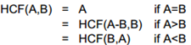

Examples:
Inputs: 12 15
Output: 3

Inputs: 30 24
Output: 6

2- Write a recursive function that calculates triangle number.

A triangle number of a positive integer is the sum of all the numbers less than or equal to that number.

For example, triangle(5) = 1 + 2 + 3 +4 + 5 = 15;
triangle(9) = 1 + 2 + 3 + 4 + 5 + 6 + 7 + 8 + 9 = 45, etc.

3- Write a recursive function that has two parameters (x and N), and returns x^{N} (x to the power of N).

Don’t use Math.Pow() function.

4- Write a recursive function that computes Liar_Liar(n).

Liar-Liar numbers are a sequence of negative numbers in which each number is two times the sum of the previous two
negative numbers. The exact formulation for the Liar-Liar sequence is:

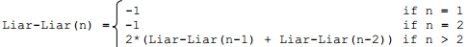

Liar-Liar( 1) = -1
Liar-Liar( 2) = -1

Liar-Liar( 3) = -4
Liar-Liar( 4) = -10
Liar-Liar( 5) = -28
Liar-Liar( 6) = -76
Liar-Liar( 7) = -208
Liar-Liar( 8) = -568
Liar-Liar( 9) = -1552
Liar-Liar(10) = -4240
Liar-Liar(11) = -11584
Liar-Liar(12) = -31648
Liar-Liar(13) = -86464
Liar-Liar(14) = -236224
Liar-Liar(15) = -645376
Liar-Liar(16) = -1763200
Liar-Liar(17) = -4817152
Liar-Liar(18) = -13160704

5- Write a recursive function to determine whether a given number is a prime or not.

6- Write a recursive function to determine whether a given number is a perfect number or not.

A number is perfect if the sum of its factors is equal to itself.

Example:
6 is perfect, because its divisors are 1, 2, and 3; and 1 + 2 + 3 = 6.
28 perfect, because its factors are 1, 2, 4, 7, and 14; and 1 + 2 + 4 + 7 + 14 = 28.

7- Write a recursive function that computes Greatest Common Divisor of X and Y: GCD(X,Y)

GCD(X,Y) is the largest D that divides both X and Y

Also prove that:
GCD(X,Y) = GCD(X-Y,Y)
GCD(X,Y) = GCD(Y,X mod Y)

Solution: find remainder using the MOD function
If the remainder ≠ 0 shift low number to high and remainder to low.
Repeat until remainder = 0.

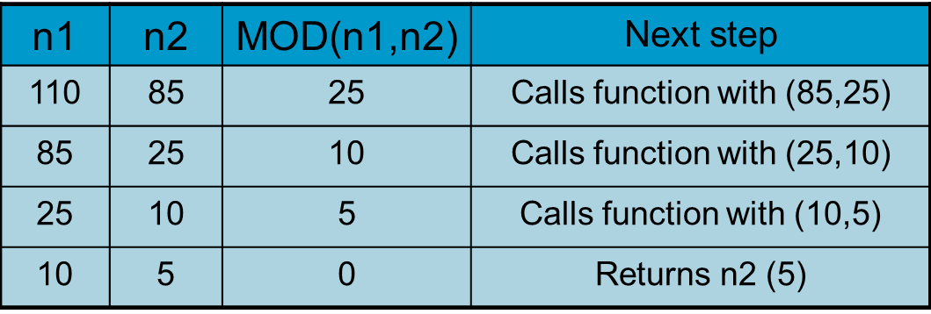

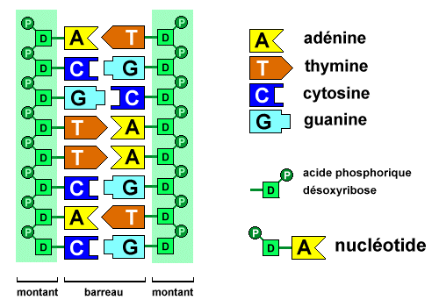
8- Write a recursive function to compute the complement of a given DNA string.
The complement of a DNA sequence is a sequence of the complementary letters (A-T, C-G) of the given sequence.

Example:
Input string: "a a a g t g c"
Output string: "t t t c a c g"


9- Write a recursive function that deletes all vowel characters from a given string.

Example:
Input: derya
Output: dry

